**A. Introduction (Background & motivation)**

**Background:**

**Guix System** is an advanced, fully free and open-source **GNU/Linux distribution** that integrates the **GNU Guix** package manager at its core. It is known for its **declarative, functional approach** to both system configuration and package management, making it a unique option in the world of Linux distributions.

Developed by the **GNU Project**, Guix System emphasizes **reproducibility**, **flexibility**, and **freedom** for the user. Unlike traditional operating systems that typically offer imperative package management, Guix enables users to define their entire system configuration in a **declarative manner**, allowing for system builds that are fully reproducible across different machines.

Guix OS is a run-time GNU/Linux distribution with a focus on reproducible and declarative system configuration. It is based on the GNU Guix package manager and is appropriate for advanced users who value software freedom and total control over their system environment.

**Motivation:**

As computing platforms become increasingly dynamic and sophisticated, there's an increasing need for reproducible, adaptable, and trustworthy systems. Guix OS provides exactly this due to functional package management that aligns itself with modern Develops and infrastructure-as-code principles**.**

Guix provides a unique approach to system management with its declarative configuration and atomic upgrades, making it an excellent subject for studying modern operating system concepts**.**

**B. Objectives**

* **Install Guix OS in a virtual environment**
* **Understand its unique package management system**
* **Explore its file system and security features**
* **Compare with traditional Linux distributions**

Install and configure Guix OS in a virtual machine**.**

Configure user account "Amanuel Gebrie".

Record any installation problems encountered and how they were resolved.

Experiment with filesystem support in Guix OS.

Use a simple example with the clone() system call.

**C. Requirements**

**i. Hardware:**

CPU: x86_64 compatible processor

RAM: At least 2 GB (4 GB recommended)

Disk Space: At least 15 GB

Virtualization support enabled in BIOS

**ii. Software:**

Virtual Machine Software: Oracle VM VirtualBox (or VMware Workstation)

Guix OS ISO Image

Host OS (e.g., Windows/Linux for virtual environment)

**In addition to this we should consider these requirements here below.**

To successfully install and run **Guix OS** in a virtualized environment (such as **Virtual Box** or **VMware**), the following hardware and software requirements must be met:

**1. Hardware Requirements**

**For Host Machine (Physical Computer Running the VM)**

* **CPU**: 64-bit x86 processor (Intel/AMD) with **hardware virtualization support** (VT-x/AMD-V)
* **RAM**: Minimum **4GB** (8GB recommended for better performance)
* **Storage**: At least **20GB free disk space** (Guix itself is lightweight, but extra space is needed for software installations)
* **Internet Connection**: Required for downloading packages and updates

**For Virtual Machine (Guix OS Installation)**

* **Virtual CPU Cores**: At least **2 cores** allocated
* **RAM**: Minimum **2GB** (4GB recommended if running GUI applications)
* **Disk Space**: **20GB dynamically allocated** (ext4 or Btrfs recommended)
* **Graphics**: **VMSVGA** (for Virtual Box) or **VMware SVGA** (for VMware) for GUI support
* **Network**: **Bridged or NAT** (for internet access)

**2. Software Requirements**

**For Host Machine**

* **Hypervisor (Virtualization Software)**:
* **Oracle Virtual Box** (≥ 6.0)
* **VMware Workstation** (≥ 15.0) or **VMware Player** (Free)
* **QEMU/KVM** (Linux users)
* **Guix Installation Media**:
* **Download the latest Guix ISO** from <https://guix.gnu.org/download/>
* **USB/DVD writer** (if installing on real hardware)

**For Guest VM (Guix OS)**

* **Boot Mode**: **UEFI or Legacy BIOS** (Guix supports both, but UEFI is preferred)
* **File system**: **ext4** (default) or **Btrfs** (for snapshots)
* **Package Manager**: **Guix** (pre-installed)
* **Desktop Environment (Optional)**:
* **GNOME** (default)
* **Xfce** (lightweight alternative)
* **No GUI** (for server/CLI-only setups)

**3. Additional Considerations**

* **Secure Boot**: **Disabled** (Guix does not support Secure Boot by default).
* **Virtualization Extensions**: Must be **enabled in BIOS/UEFI** (VT-x/AMD-V).
* **Networking**: Ensure **NAT or Bridged** mode is configured for internet access during installation.
* **Guest Additions/VM Tools**: Not required (Guix uses open-source drivers).

**Conclusion**

* Guix OS has modest hardware requirements, making it suitable for virtualized environments. The key requirements are.
* A **64-bit CPU with virtualization support.**
* **4GB+ RAM** on the host machine.
* **20GB+ disk space.**
* A **compatible hypervisor** (Virtual Box, VMware, or QEMU).
* **Internet access** for package downloads.

Once these requirements are met, Guix can be installed and configured efficiently in a virtual machine for learning, development, or experimentation.

**D. Installation Steps**

**1. first, Download Guix ISO**: Get the installation image from <https://guix.gnu.org/download/>.

we get the guix OS on the offitial website https://guix.gnu.org/en/download.

**2,Create a New Virtual Machine**

**To install Guix GNOME on a virtual machine, we create one with these parameters. We use AQEMU Virtual Machine.**

**•64-bit PC.**

**•2 GigaByte memory.**

**•20 GigaByte hard disk.**

**•Networking enabled.**

**•Default graphics option.**

**•BIOS Legacy booting mmode.**

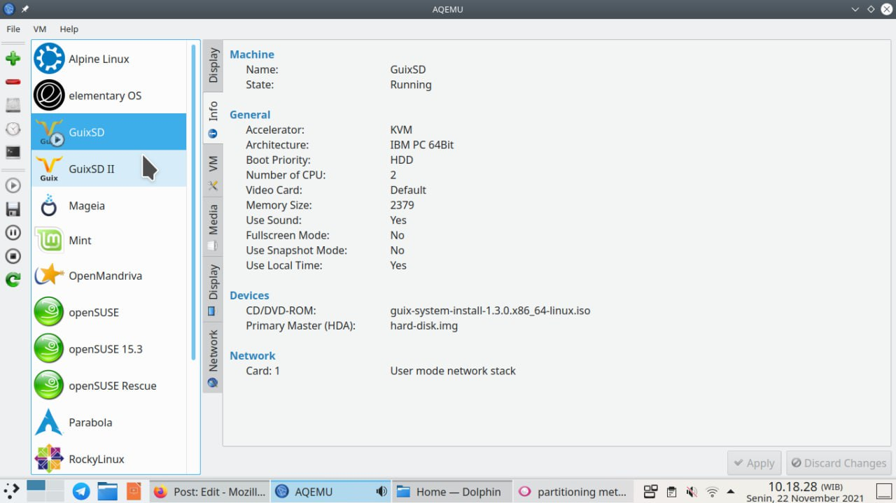

(AQEMU displaying the virtual machine configuration for Guix System)

**3.Insert guix os file**

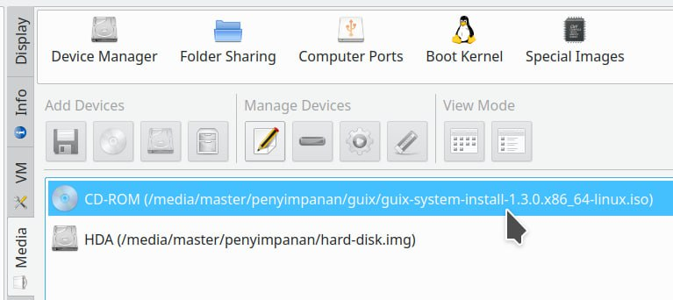Then, after we have created the virtual machine, next we insert the operating system file into it. To do so, on unstartedGuixvm, select Media, click Add CD/DVD ROM, insert the guix-system-*.iso file, image file inserted. Proceed to next section.

(ISO image preparation on the virtual machine)

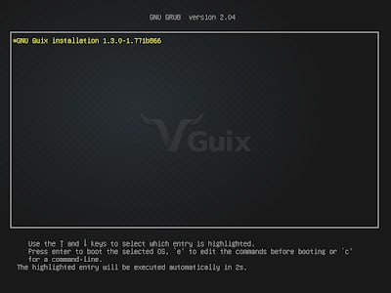**4, Boot up guixOS:**Once we put the image file in place, We then boot the virtual computer to install Guix System installer. To do this, we double click on the Guixvm, click menubar VM, click Start, a display port will be opened as a monitor, Guix System installer will be shown, you are now ready to install Guix System. Proceed to next.

(Guix System when booting into its installer)

# **How To Play**

# Guix installer does not allow mouse click interactions. Thus, to navigate the system installer, press TAB and Shift+TAB to jump from one choice to another one and back, press SPACE to give check mark, and press ENTER to select an option.

# 5, user identity

# • We Select language

# • We Select territory

# • We Select installation type

# • We Select a timezone

# • We Select a keyboard layout

# • Name your computer

# 1 . Locale language: We choose English and continue.

# 

2. Locale location: select United States and continue.

3. GNU Guix install: select Graphical install. option and continue.

4. Time zone: select a time zone e.g. Asia/Jakarta.

5. Keyboard layout: select English (US).

6. Hostname: select a name for your Guix computer e.g. we use 'master'. Continue to next step.

6. System set up

•Substitute server discovery

•Create administrator account

•Create user account

• Select a desktop environment

•\t Enable network

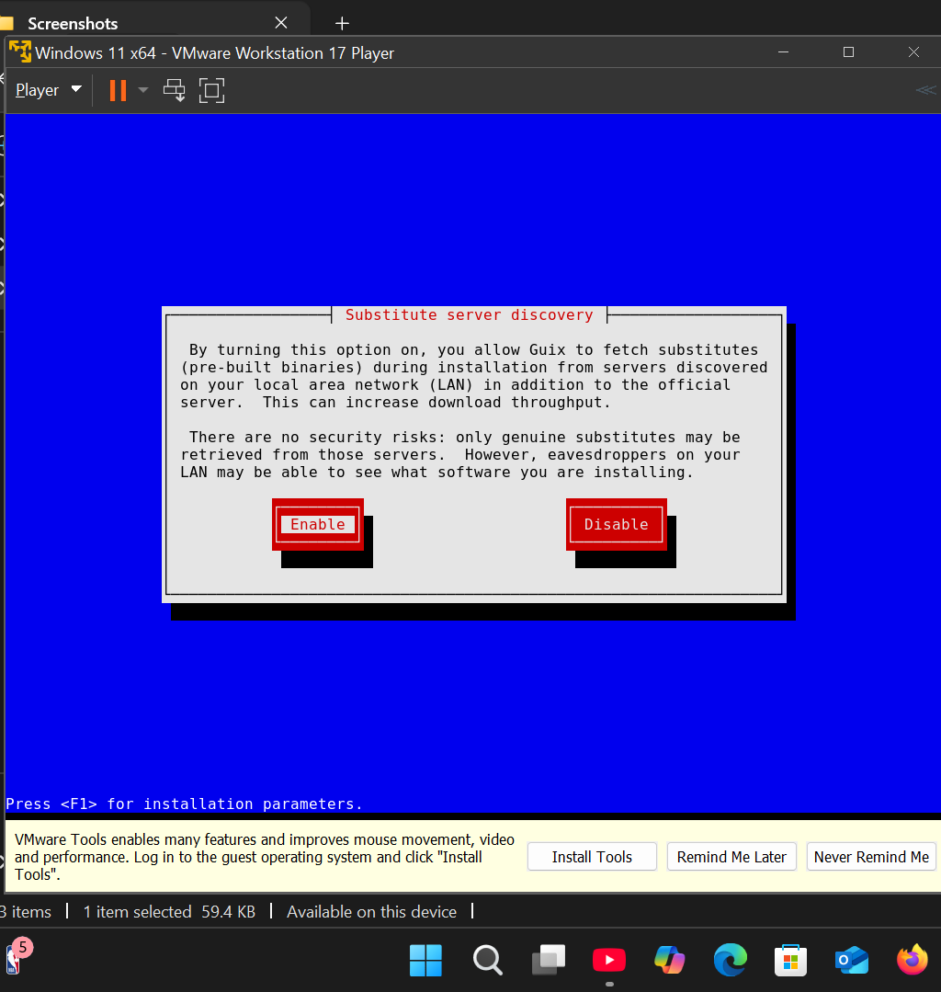

1. Substitute server discovery: select Enable and continue

2. System administrator password: create a root user password.

3. Building a user: assign yourself a username and a password.

4. Desktop environment: check box beside GNOME from the list.

5. Network service: select Mozilla NSS Certification and go to next step.

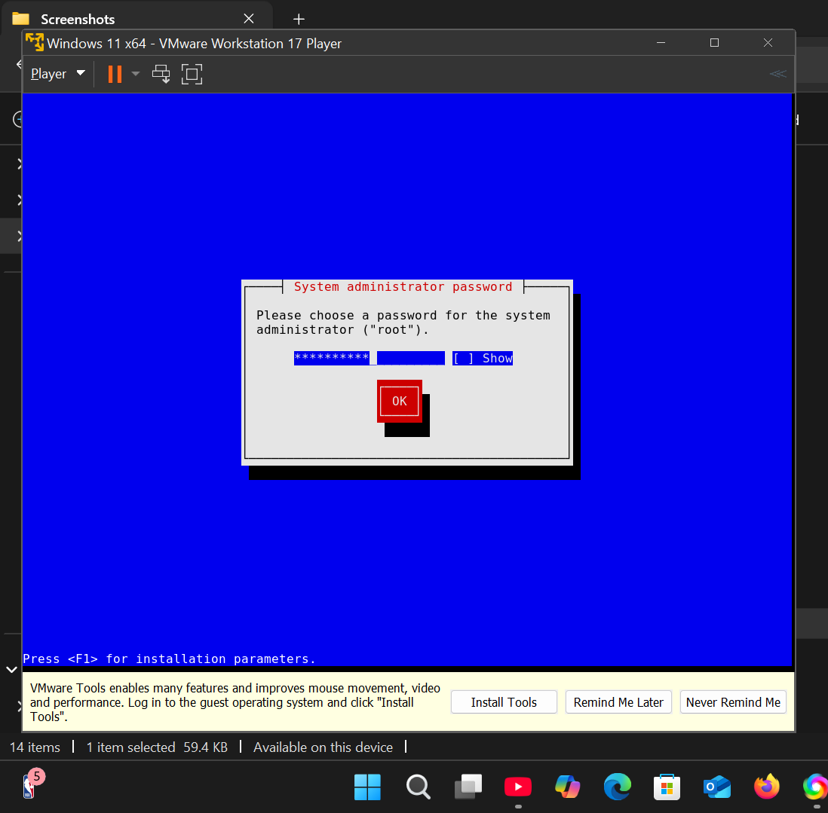

**(System administrator password)**

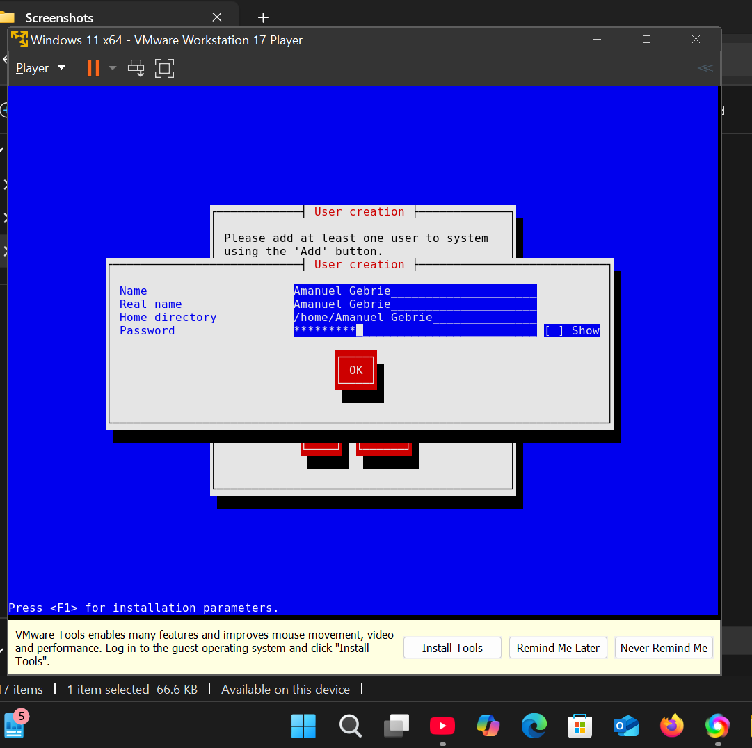

**(User creation)**

**This is desktop environment**

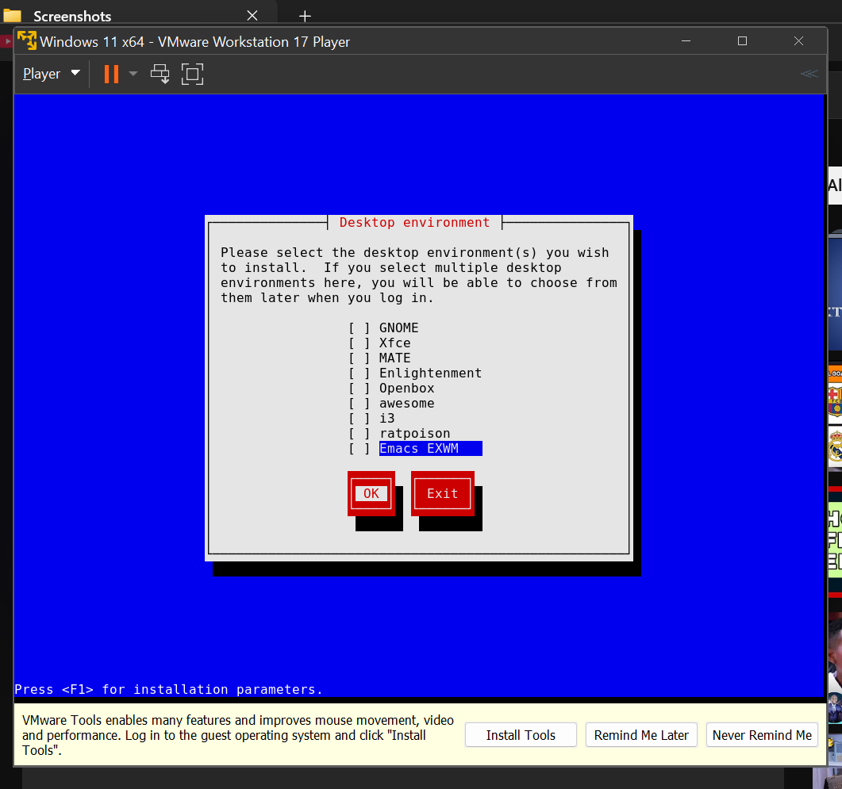

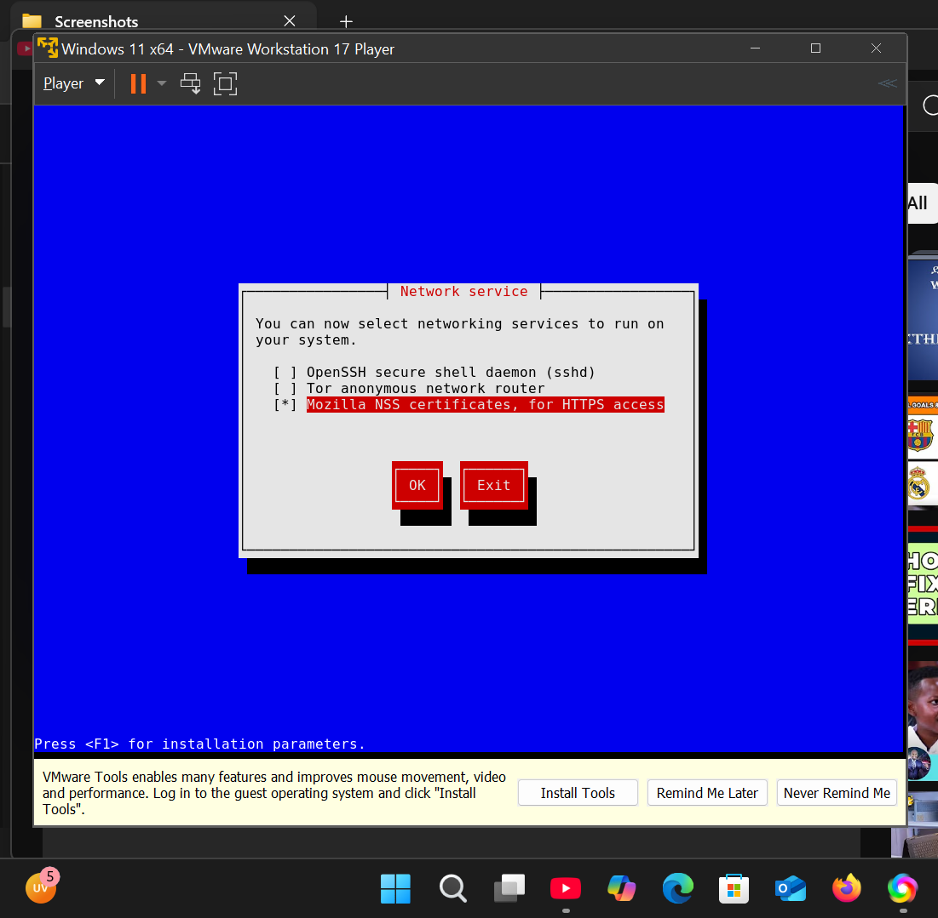

**( This is the Network service)**

**7.partitioning,processing and finishing**

**•**Stare Guided partitioning

•Select disk

•Select partitioning scheme

•Make partitions required

• Verify the summary in code form

•Start the real installation

•Wait patiently for the process to finish

1, Partitioning option: select Guided - using entire disk.

2. Disk: select the virtual machine's hard disk. In this scenario, we select ATA QEMU HARD DISK (20GB).

3 .attrition Partition scheme: select Everything is one partition.

4. Guided partitioning: the installer will display a proposal of disk partitions that will be formatted. Accept it by selecting OK. Continue.

5. Format disk?: accept this by selecting OK.

6. Preparing partitions: please wait for the disk formatting process is taking place.

7. Configuration file: the installation plan will be displayed in form of code written in a language called Scheme. Accept this by selecting OK.

8. Waiting: the installation process will take place. If this process takes place, don't close your internet connection and don't shut down the virtual machine. Wait for a few minutes until you are faced with a final message saying "Please ENTER to continue".

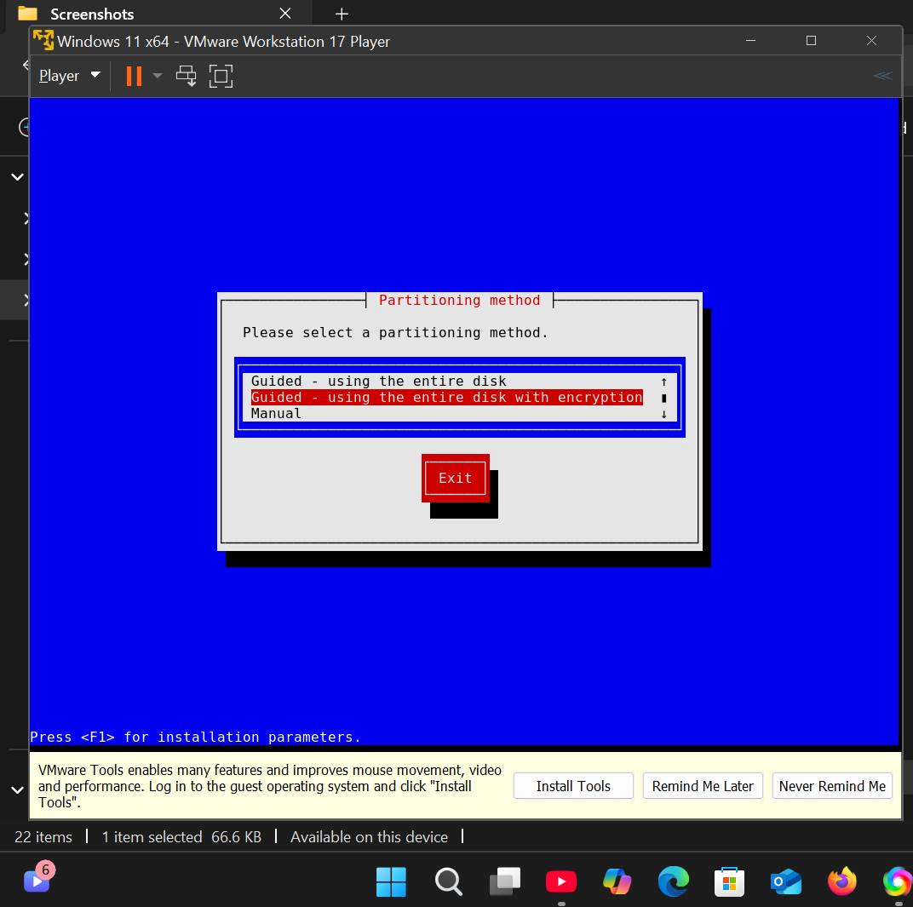

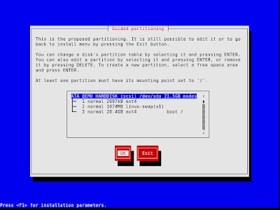 Partitioning method

Guided partitioning

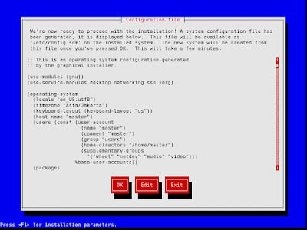

(here is Configuration file)

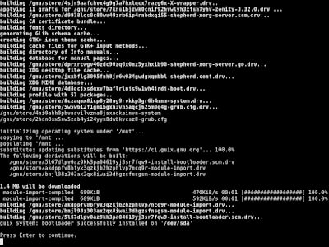

Here is the actual installation process

**8. Restart and login**

Once finished, the installer will ask you to Reboot then press Enter and you should be able to see Guix login screen like below.

